1. Run *nslookup* to obtain the IP address of a Web server in Asia. What is the IP address of that server?

Answer: 198.74.52.127 is Non-authoritative DNS server’s IP address as displayed in the nslookup results

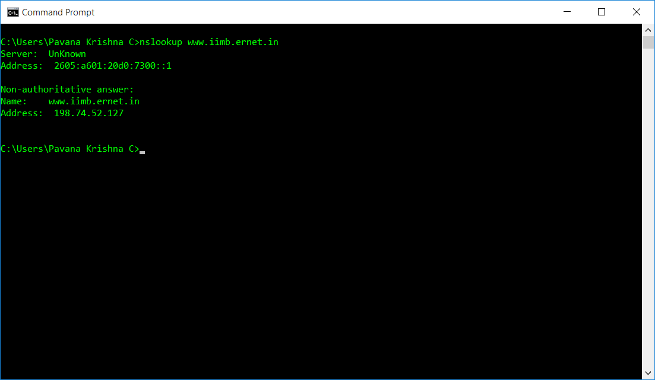

1. Run *nslookup* to determine the authoritative DNS servers for a university in Europe.

Answer:

The Primary Name Server nighthawk.dns.ox.ac.uk is the authoritative DNS server for the Oxford University.

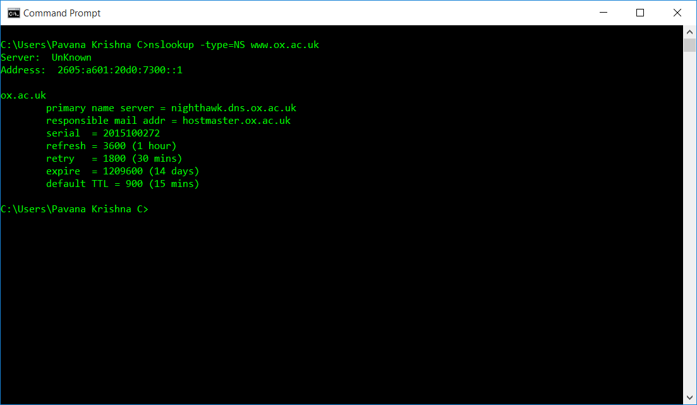

1. Run *nslookup* so that one of the DNS servers obtained in Question 2 is queried for the mail servers for Yahoo! mail. What is its IP address?

Answer: The IP Address of the DNS server of the Oxford University is 163.1.2.189

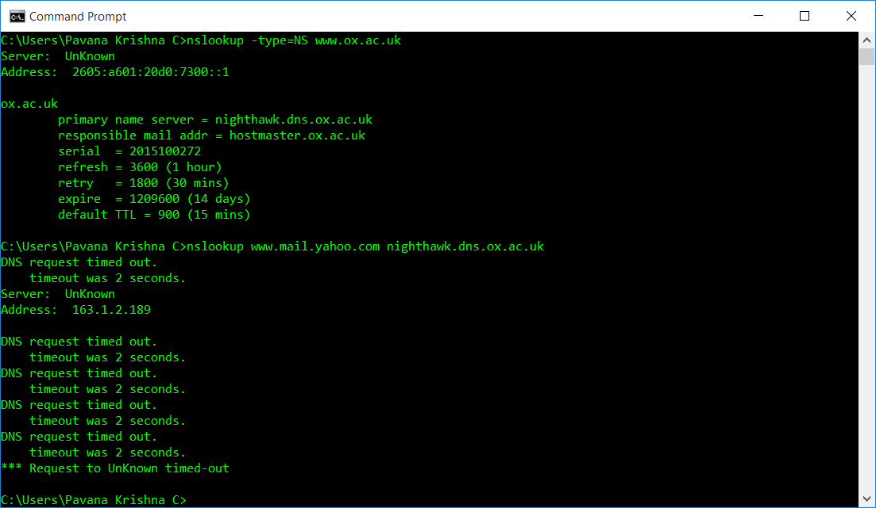

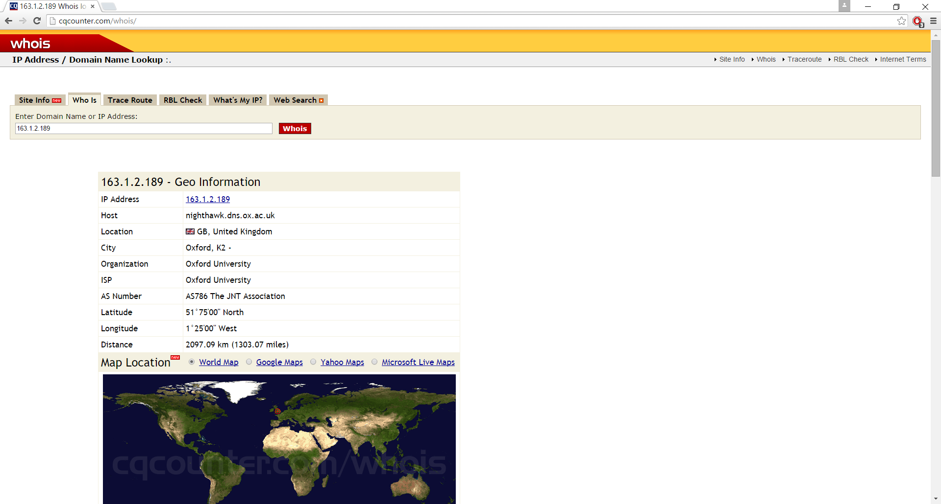

The IP Address of the Yahoo mail DNS server is 74.6.50.150

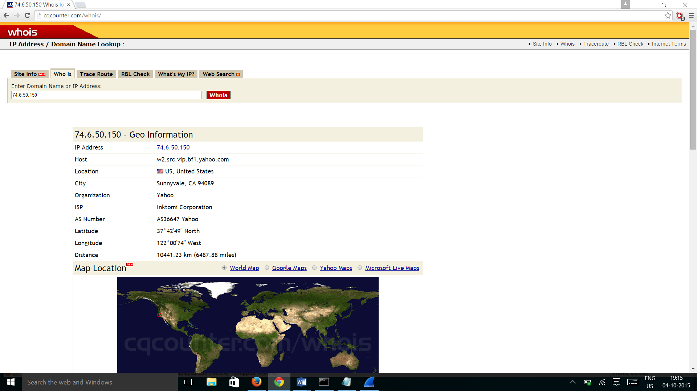

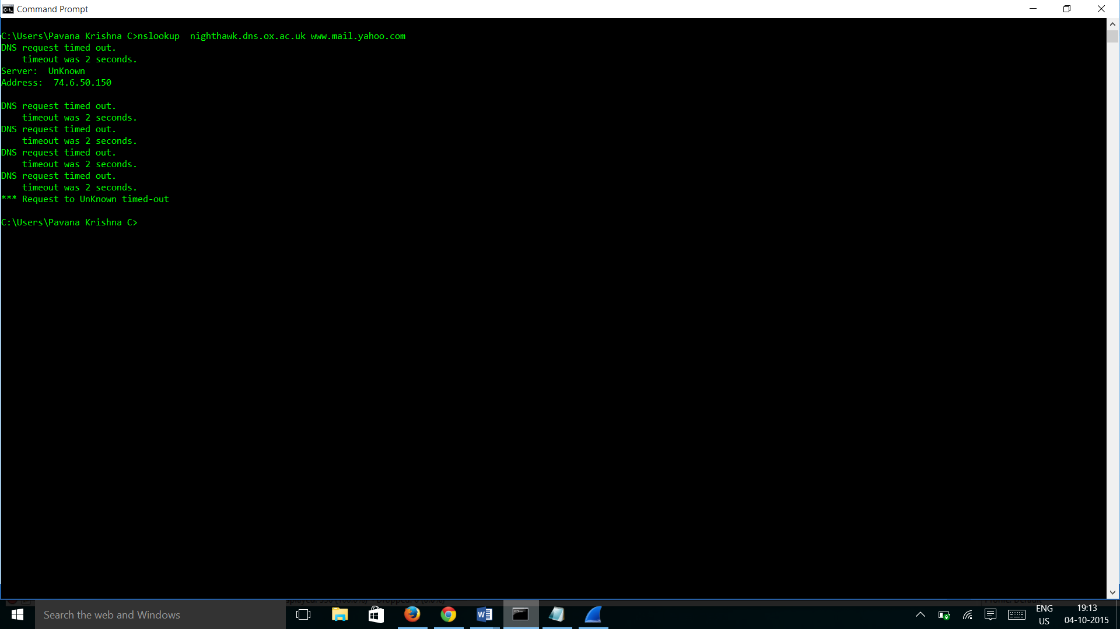

1. Locate the DNS query and response messages. Are then sent over UDP or TCP?

Ans: Both DNS Query and Response messages are sent over UDP as shown below in the screens of DNS Query and Response messages.

DNS Query

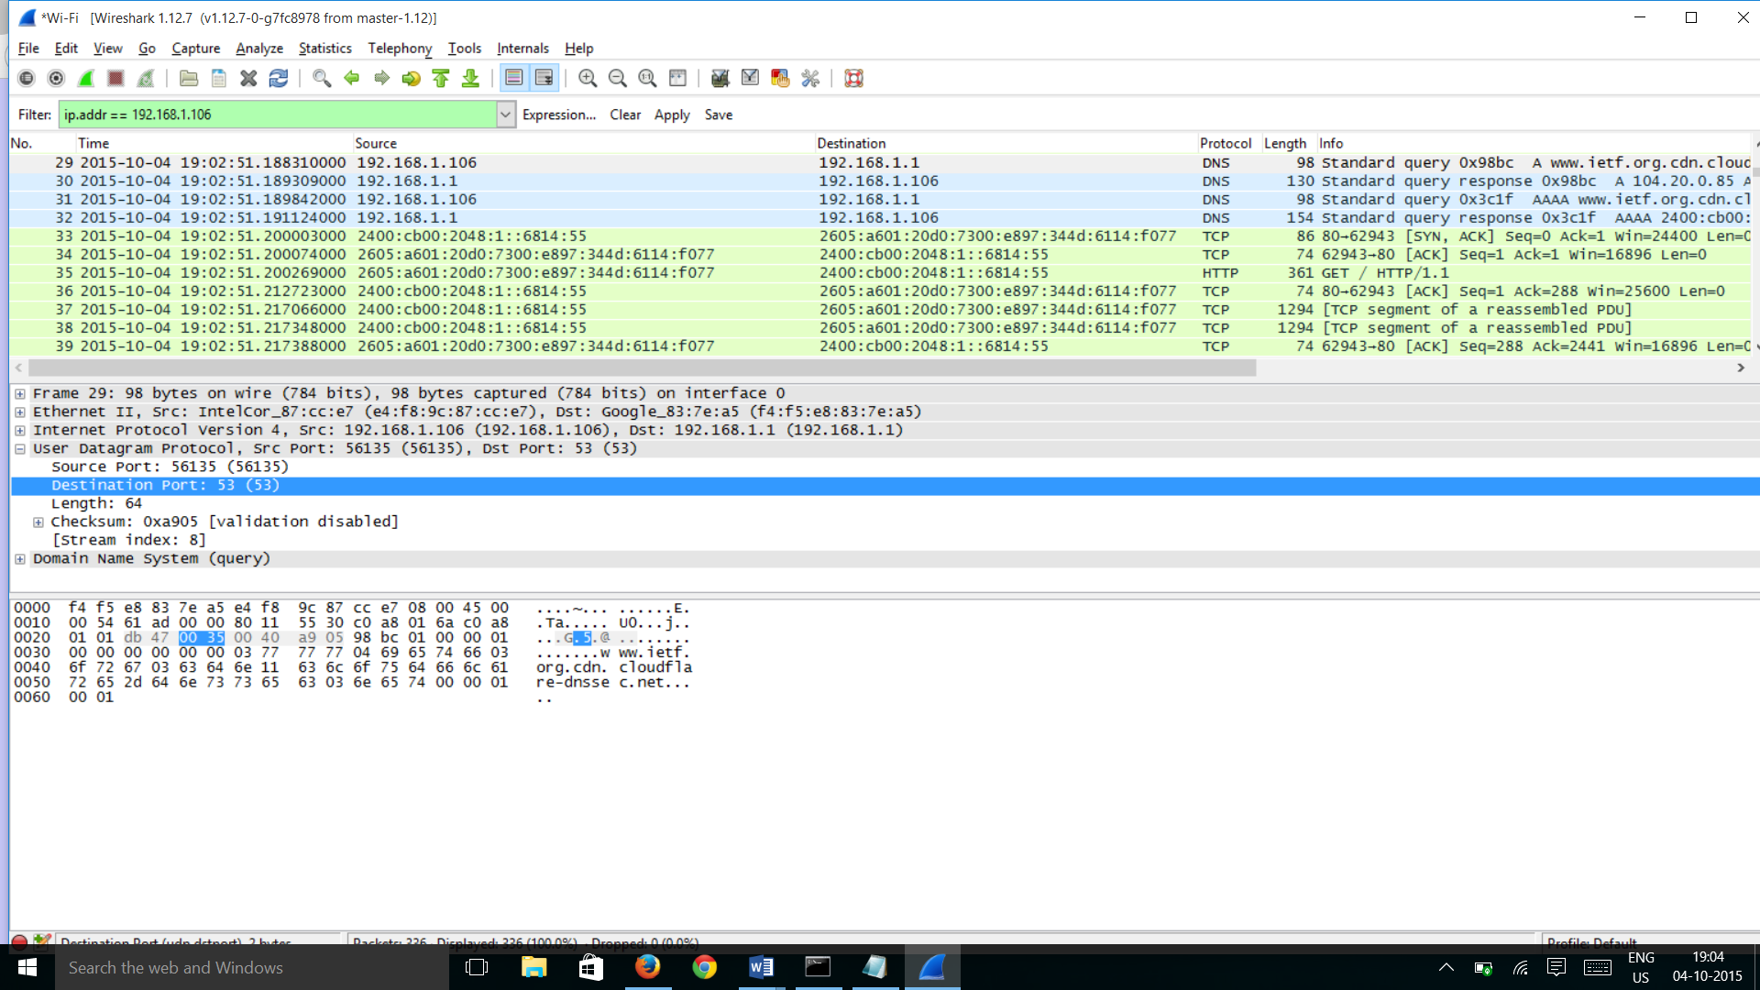

DNS Response

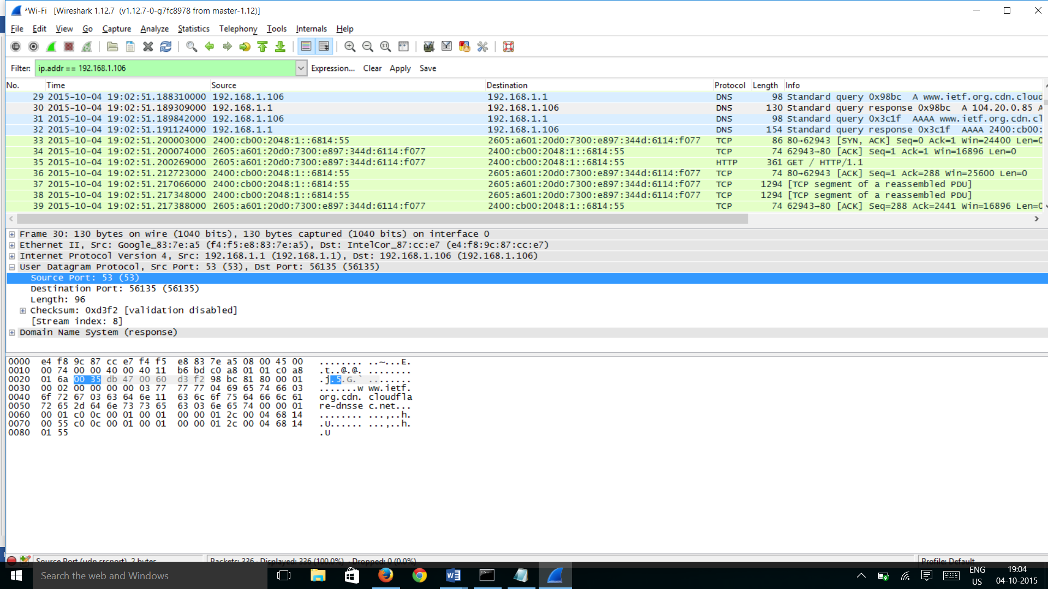

1. What is the destination port for the DNS query message? What is the source port of DNS response message?

Answer: The Destination port for the DNS Query message is 53

DNS Query



DNS Response



The Source port for the DNS Response message is 53

1. To what IP address is the DNS query message sent? Use ipconfig to determine the IP address of your local DNS server. Are these two IP addresses the same?

Answer:

The Destination of the Query message is 192.168.1.1 which is same as the Local DNS server IP address.

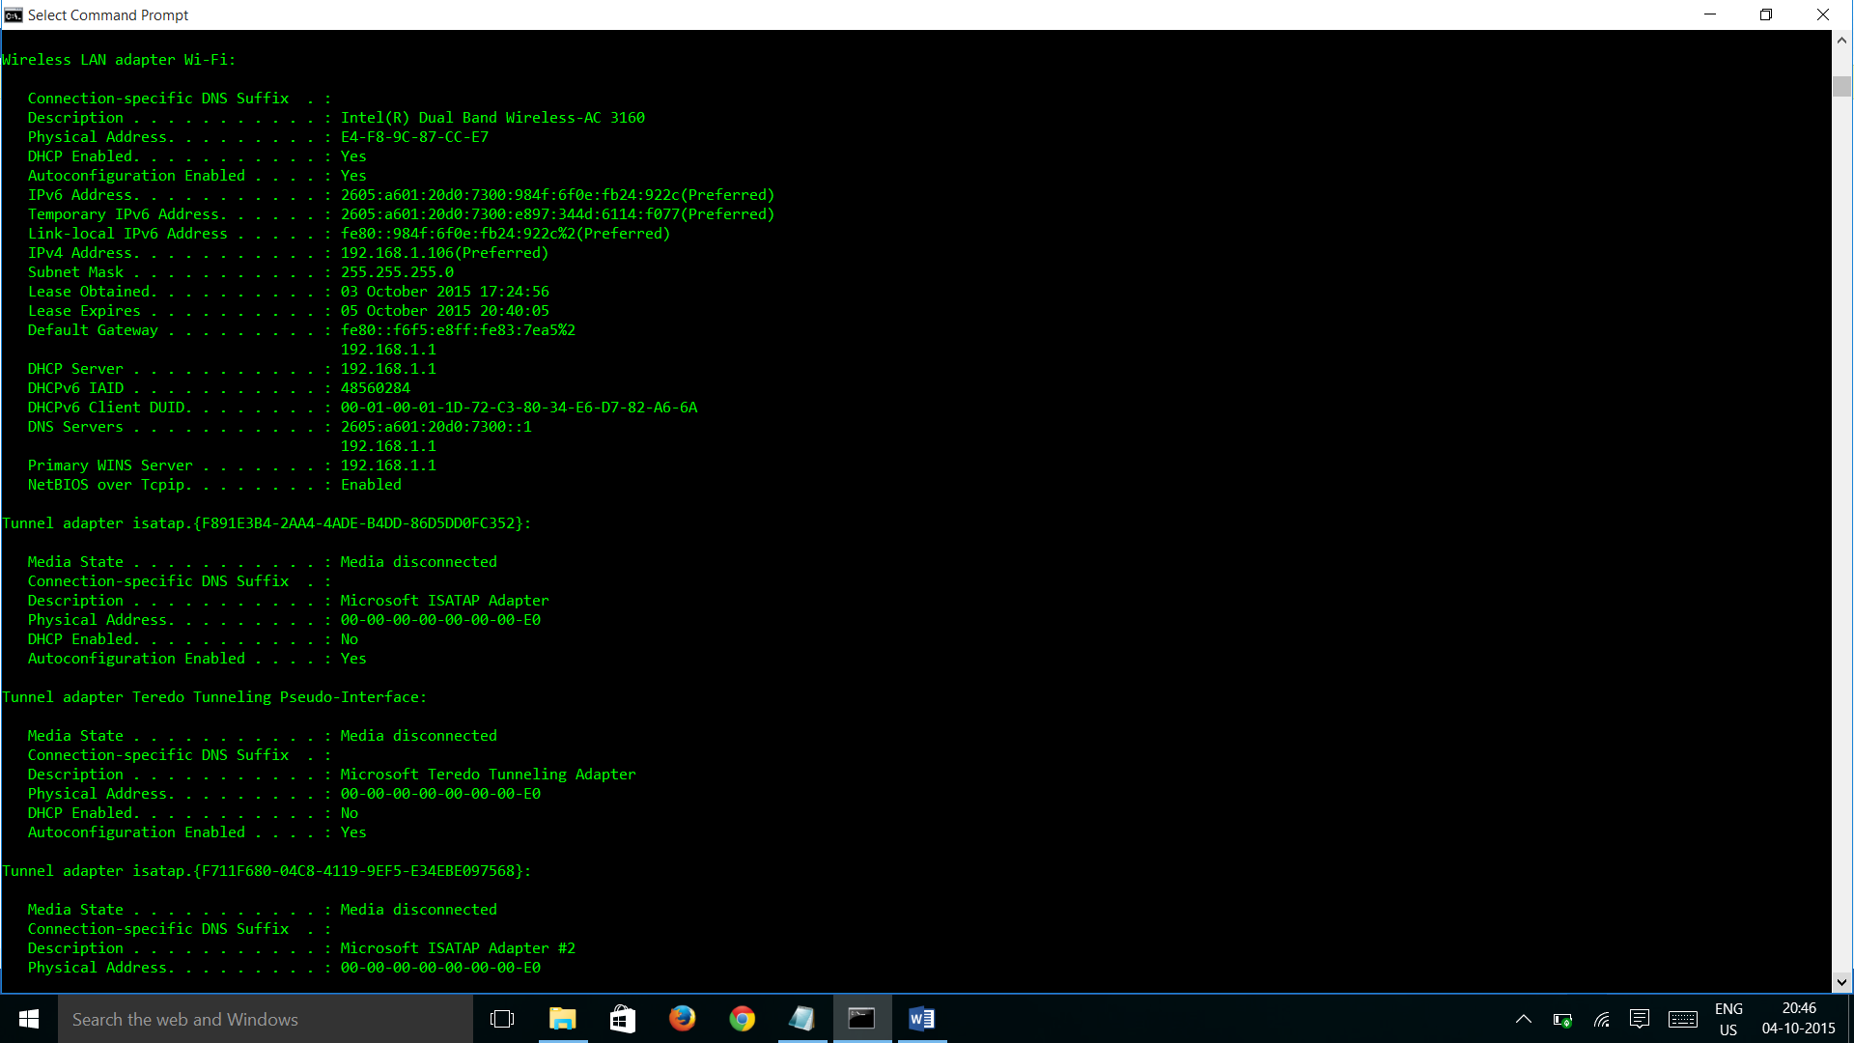

1. Examine the DNS query message. What “Type” of DNS query is it? Does the query message contain any “answers”?

Answer: The DNS Query message is a standard query as per the info tab and its Type is A and the answers value is 0.

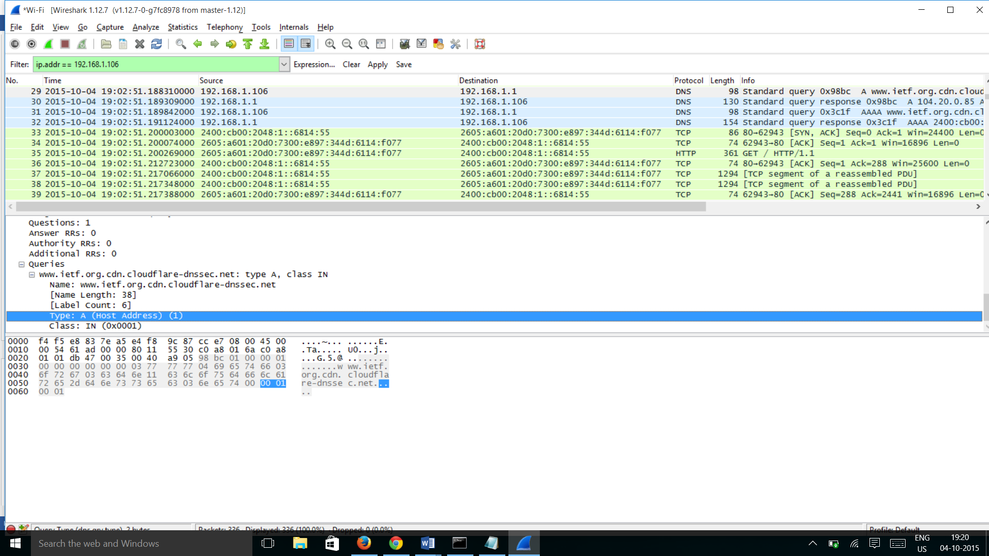

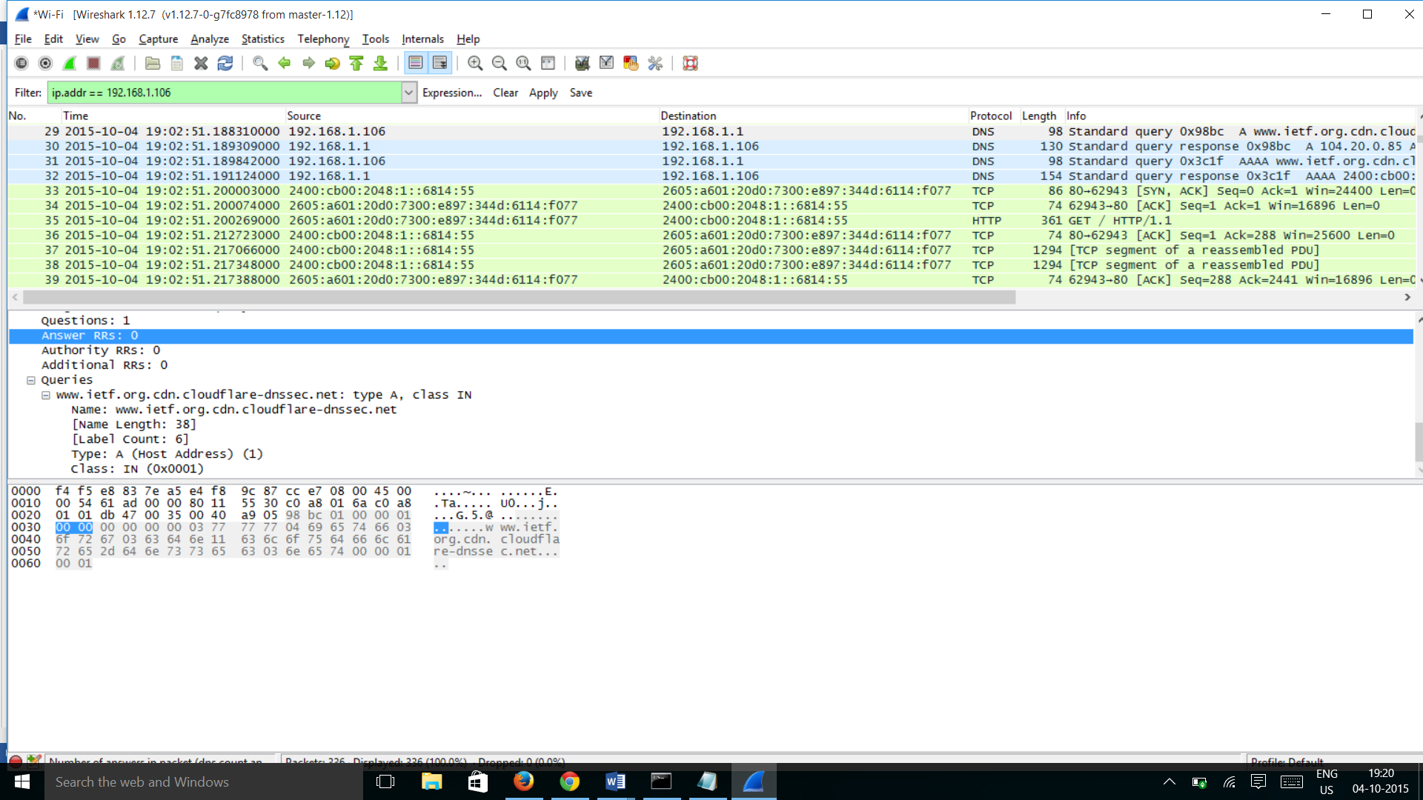

1. Examine the DNS response message. How many “answers” are provided? What do each of these answers contain?

Ans:

There are three answers provided in the DNS response message and the answers contain the websites address, Class, Time to live, data length Type etc.

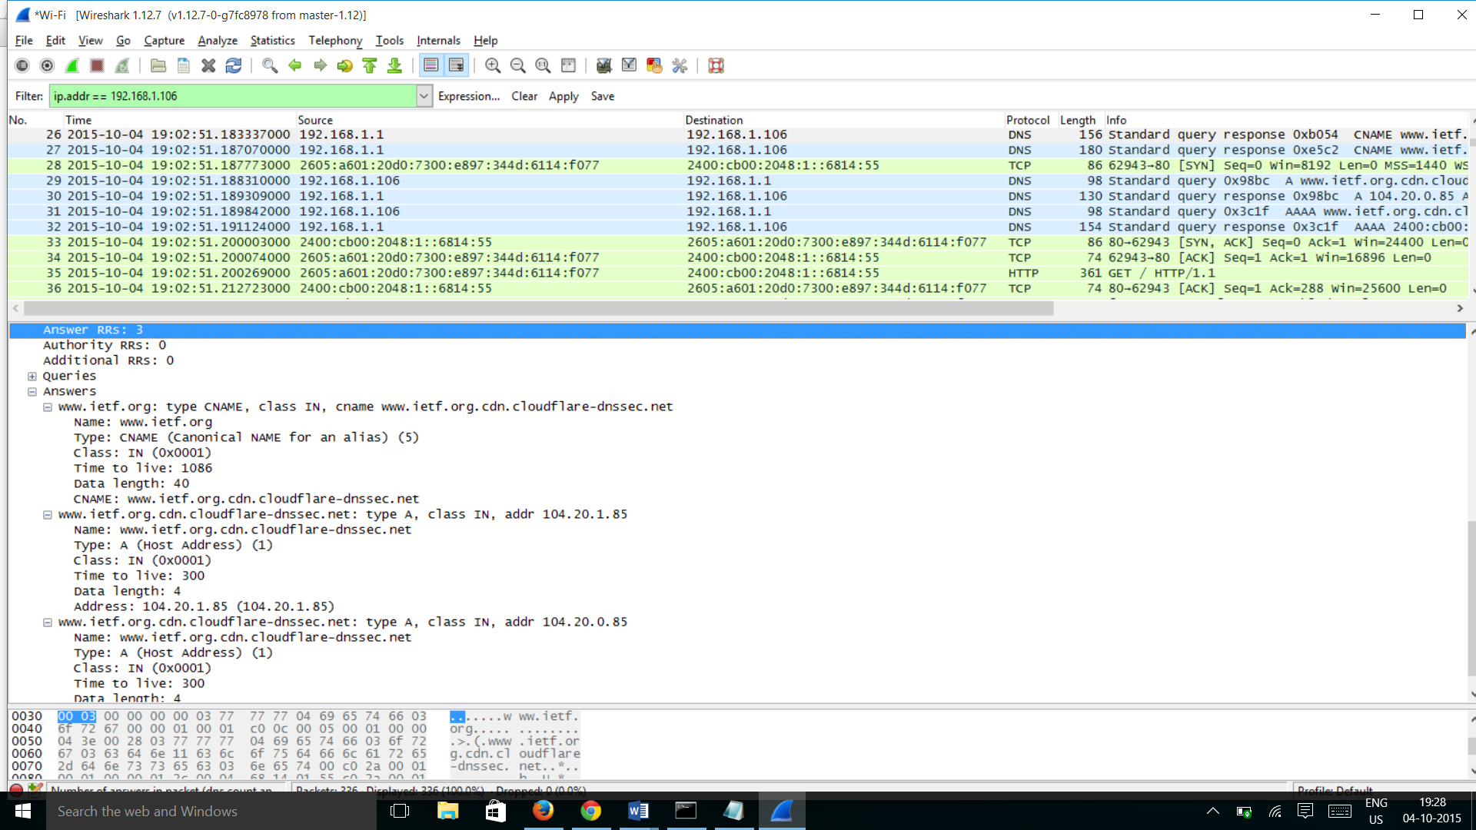

1. Consider the subsequent TCP SYN packet sent by your host. Does the destination IP address of the SYN packet correspond to any of the IP addresses provided in the DNS response message?

Answer: Yes the destination IP address of the SYN packet corresponds to the IP address provided in the DNS response message

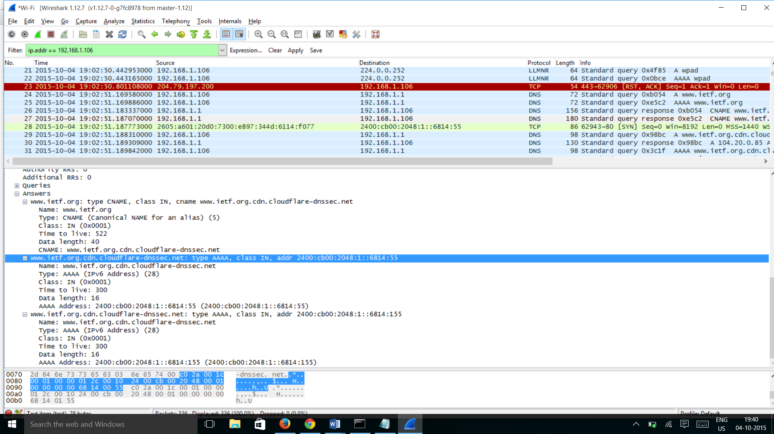

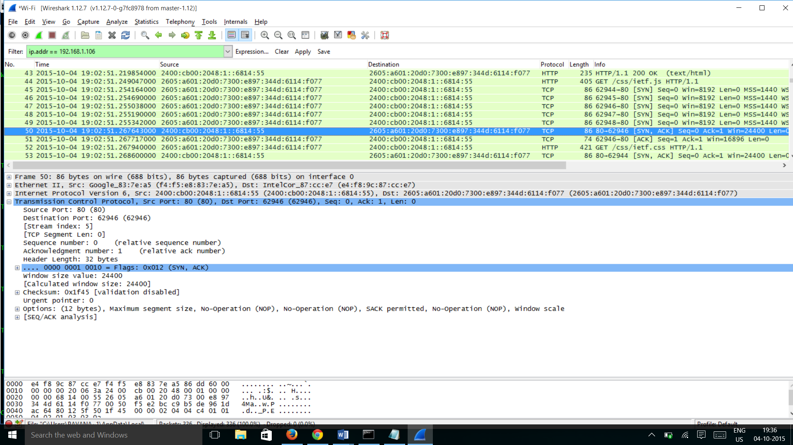

1. This web page contains images. Before retrieving each image, does your host issue new DNS queries?

Answer: No there is no new DNS Query before retrieving each image.

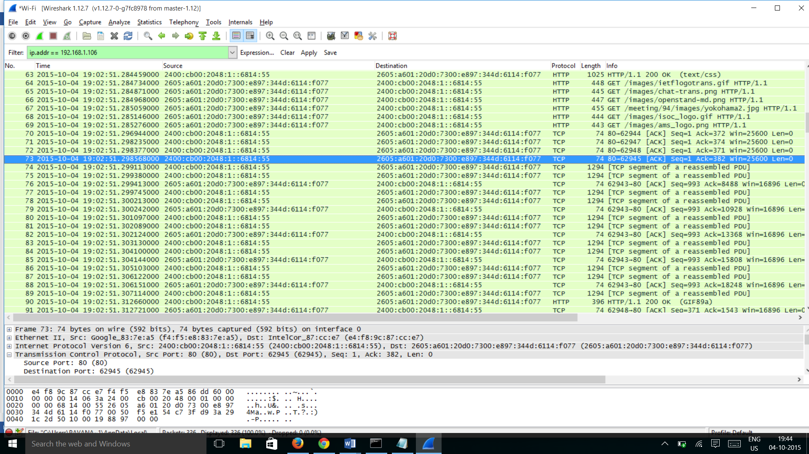

1. What is the destination port for the DNS query message? What is the source port of DNS response message?

Answer: The destination port for the DNS Query message is 53 and the Source port of DNS response message is 53.

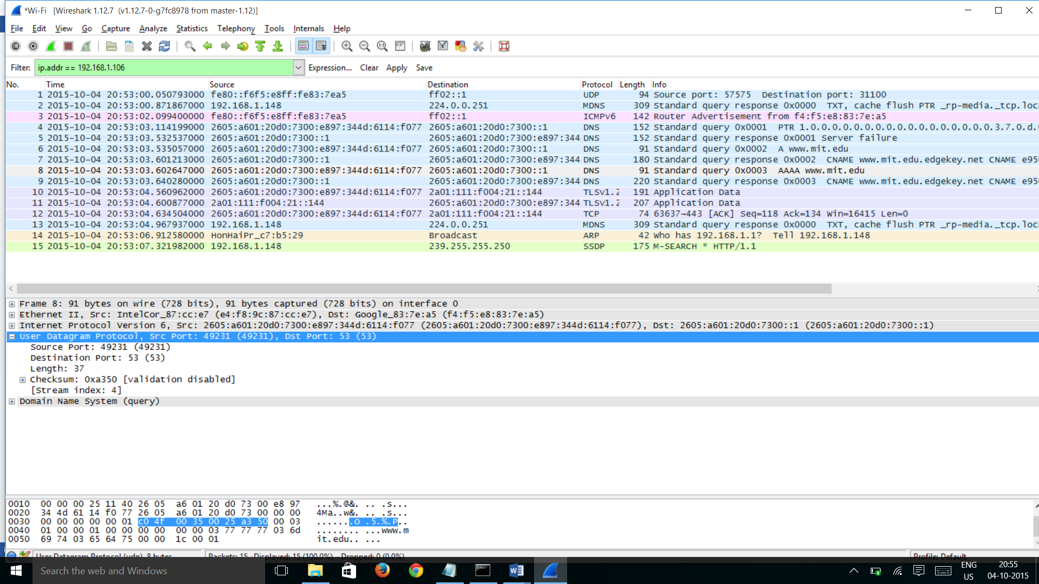

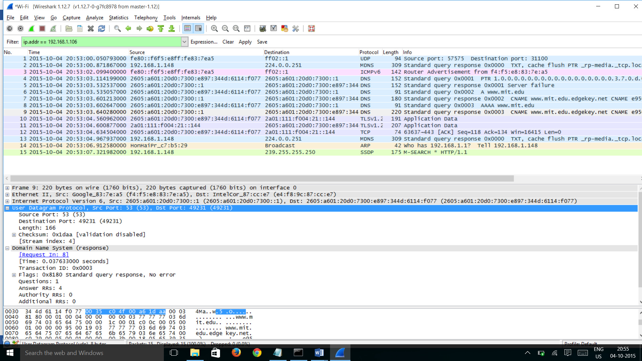

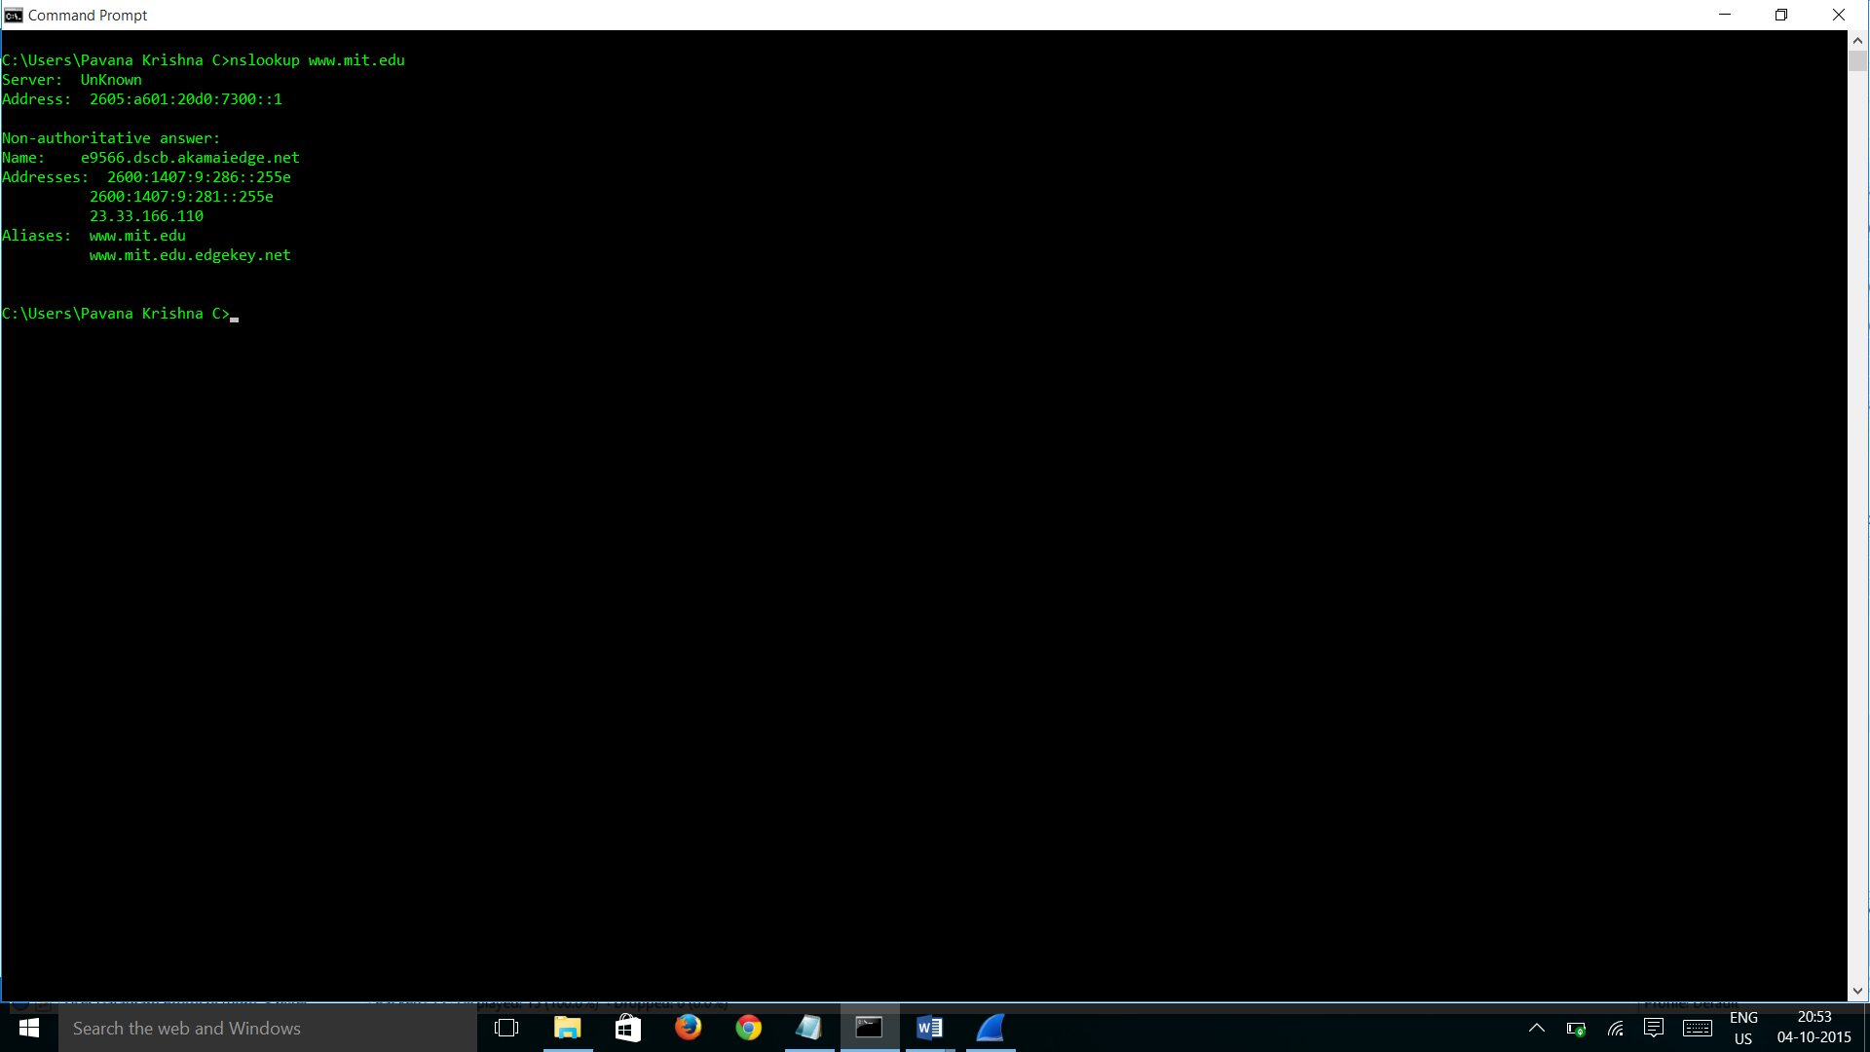

1. To what IP address is the DNS query message sent? Is this the IP address of your default local DNS server?

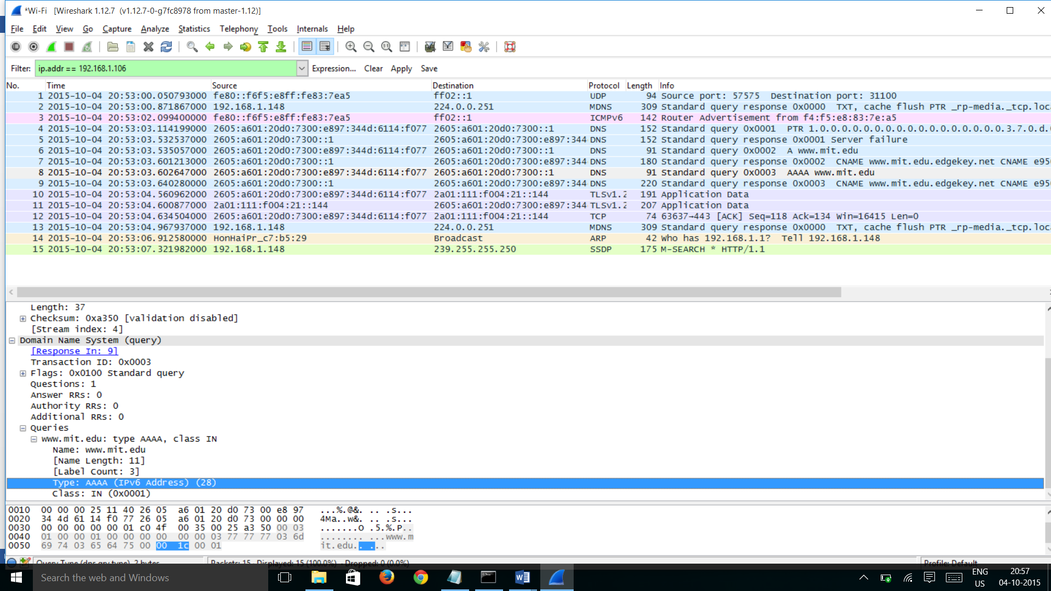

The address of the destination is 2605:a601:20d0:7300::1 and this is same as the local dns server address.



1. Examine the DNS query message. What “Type” of DNS query is it? Does the query message contain any “answers”?

Ans: Type – AAAA standard Query and there are no answers in the query message

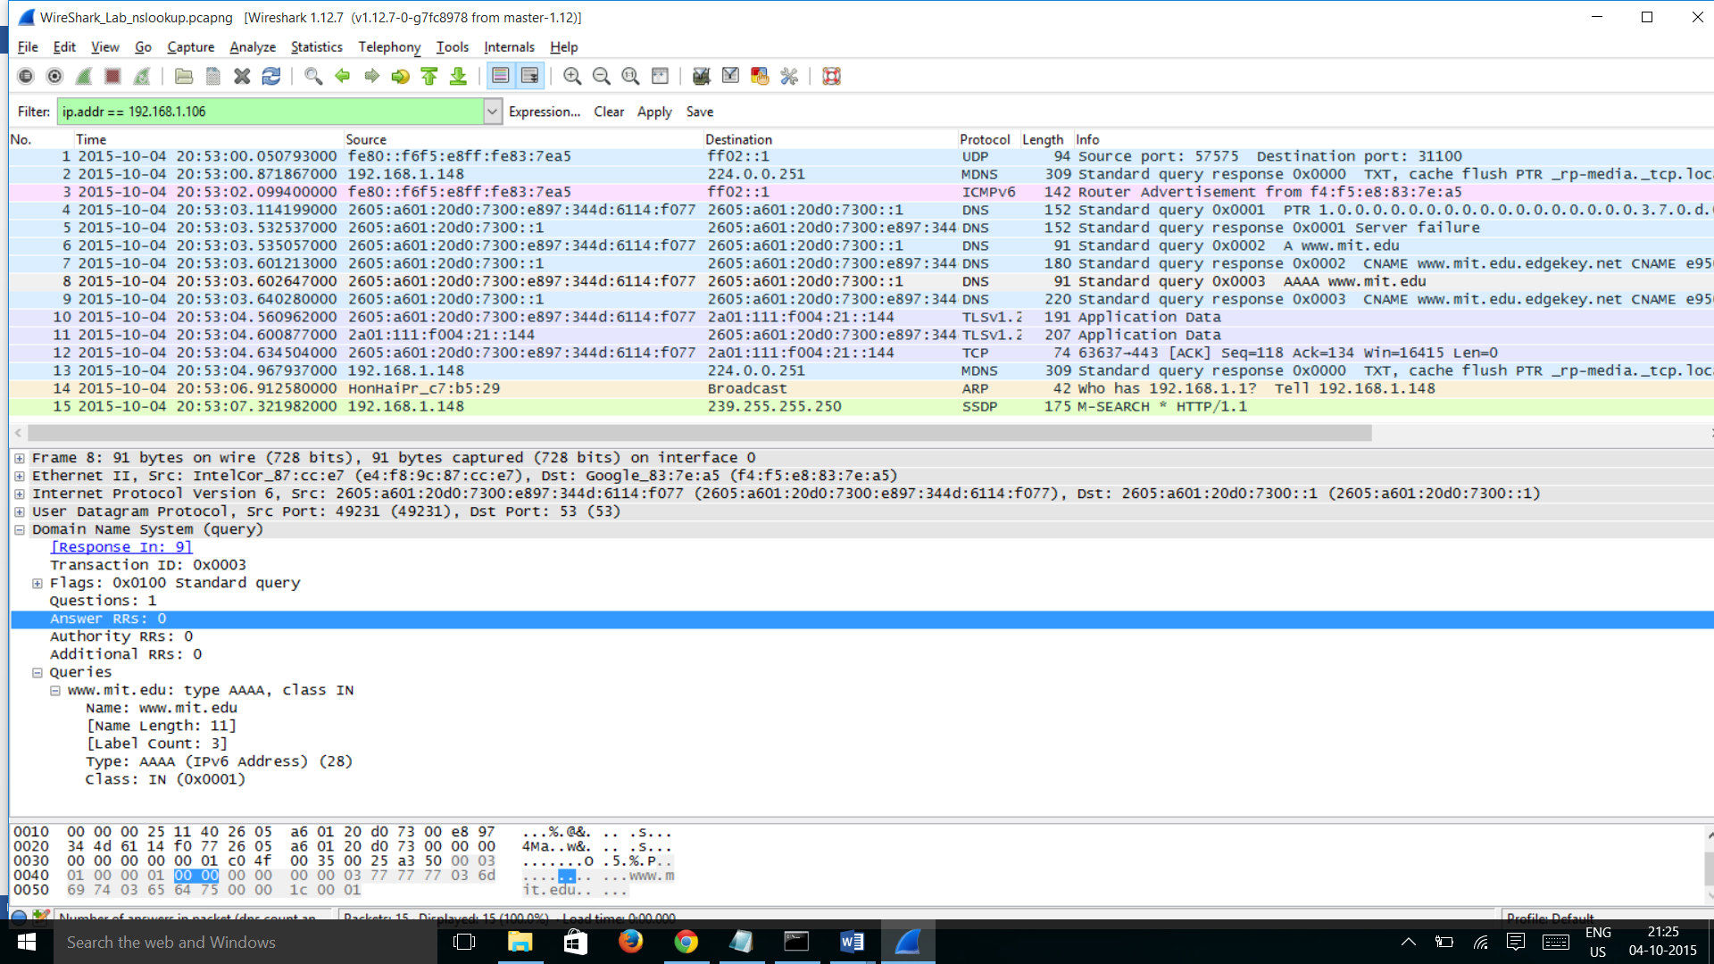

1. Examine the DNS response message. How many “answers” are provided? What do each of these answers contain?

Answer: The DNS response message contain 4 answers and they have information like website name, address, type, class etc.

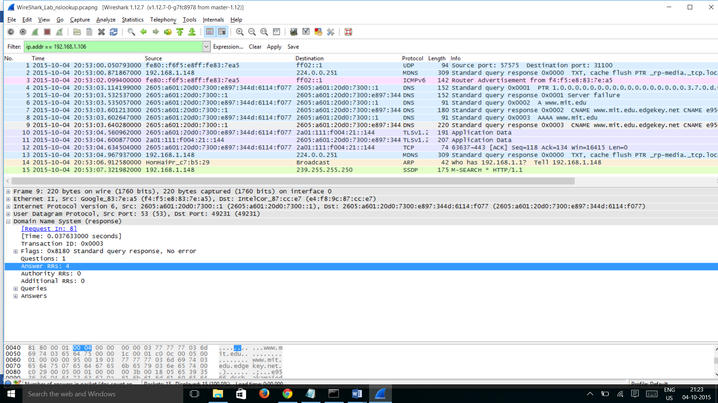

1. Provide a screenshot.

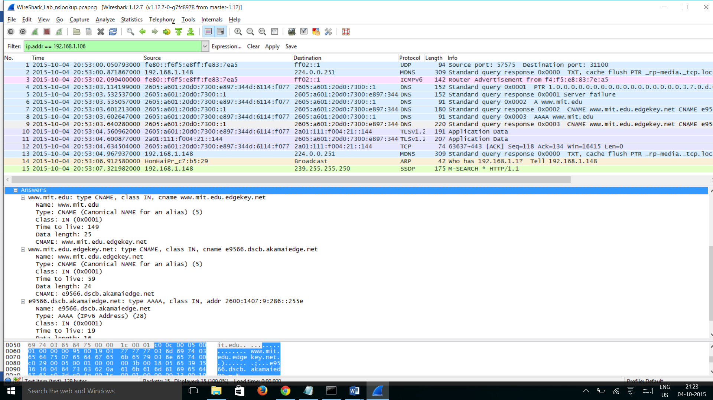

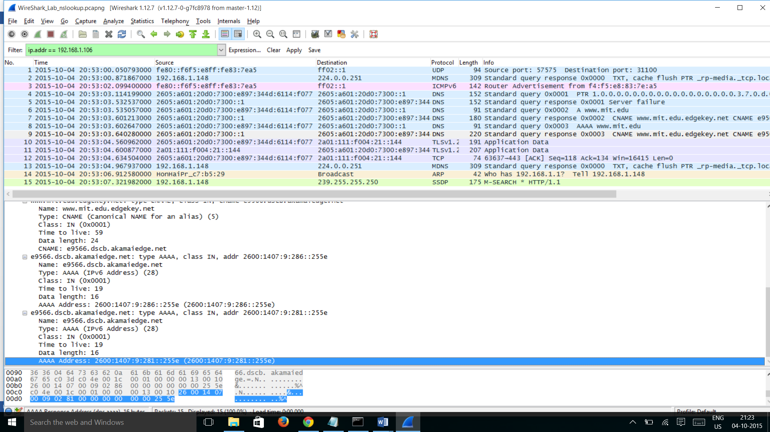

1. To what IP address is the DNS query message sent? Is this the IP address of your default local DNS server?

Answer: 2605:a601:20d0:7300::1 is the IP address to which the DNS query message sent and it is the default local DNS server.

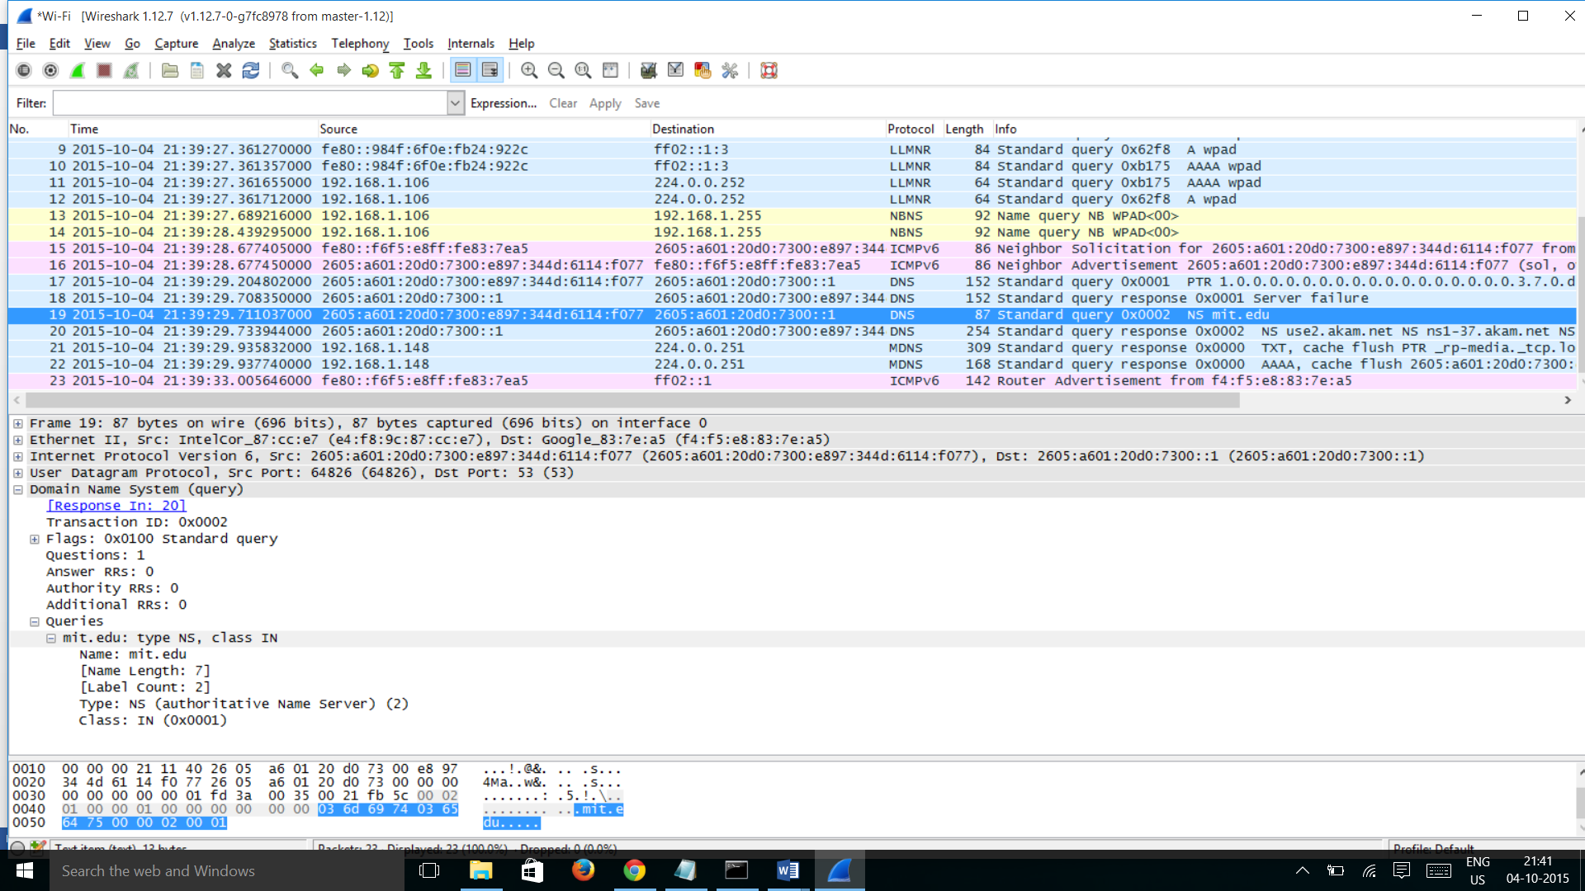

1. Examine the DNS query message. What “Type” of DNS query is it? Does the query message contain any “answers”?

Answer: It is a standard DNS query and its Type is NS (authoritative Name Server)(2) and it has no answers

1. Examine the DNS response message. What MIT nameservers does the response message provide? Does this response message also provide the IP addresses of the MIT namesers?

Answer: The response message contains name servers in the Answers section. The name servers provided in the Answers section are the same as shown in nslookup. The IP address of the name servers will be under additional records right under answers, in this case there is no additional records under the answers section.

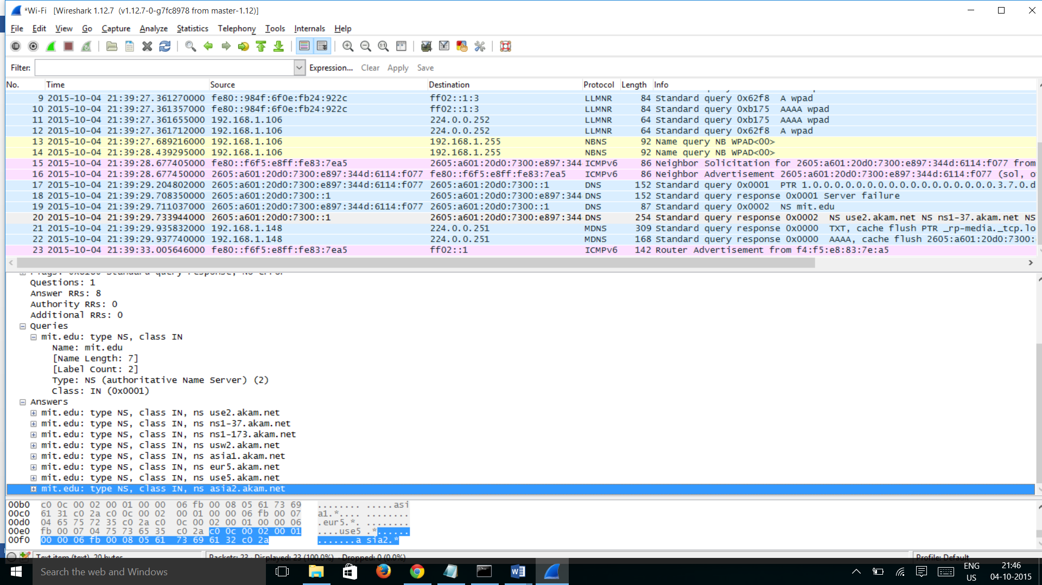

1. Provide a screenshot.

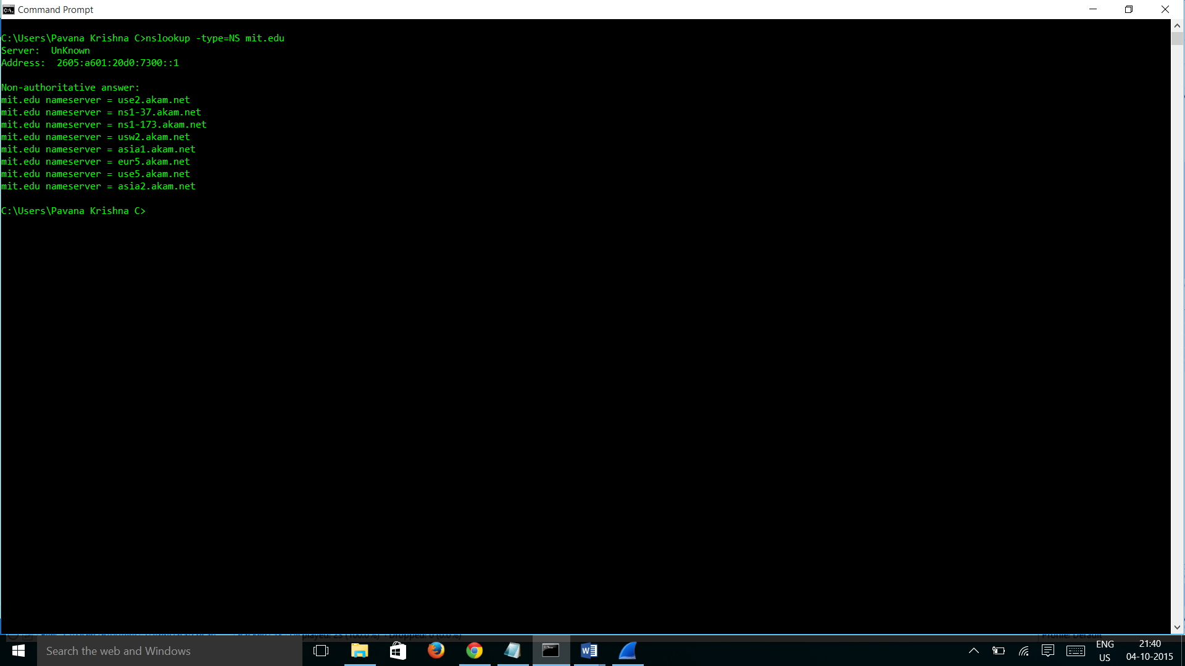

1. To what IP address is the DNS query message sent? Is this the IP address of your default local DNS server? If not, what does the IP address correspond to?

Answer: DNS query message sent to IP address 18.72.0.3. No this is not the IP address of the default local DNS server and it is the IP address of Bitsy.mit.edu

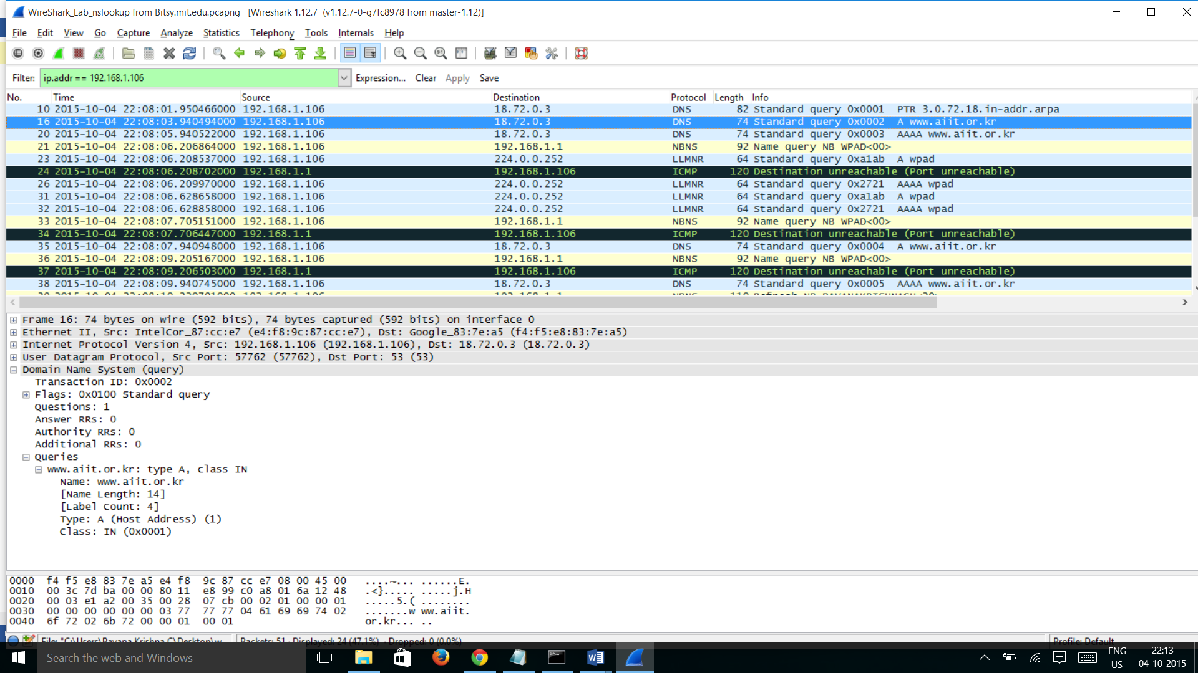

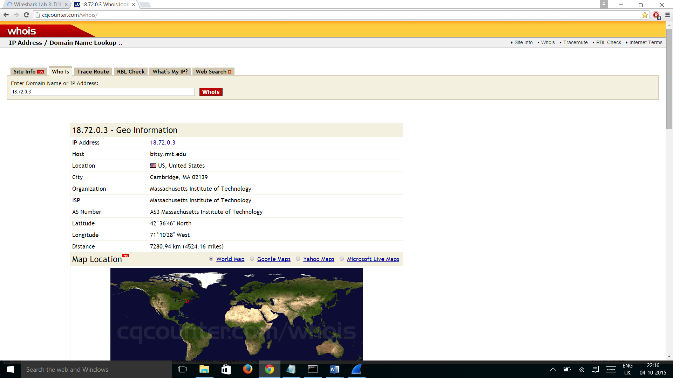

1. Examine the DNS query message. What “Type” of DNS query is it? Does the query message contain any “answers”?

Answer: DNS Query message is a standard query of Type A and the query message contain no answers as shown in the above screenshot.

1. Examine the DNS response message. How many “answers” are provided? What does each of these answers contain?

Answer:

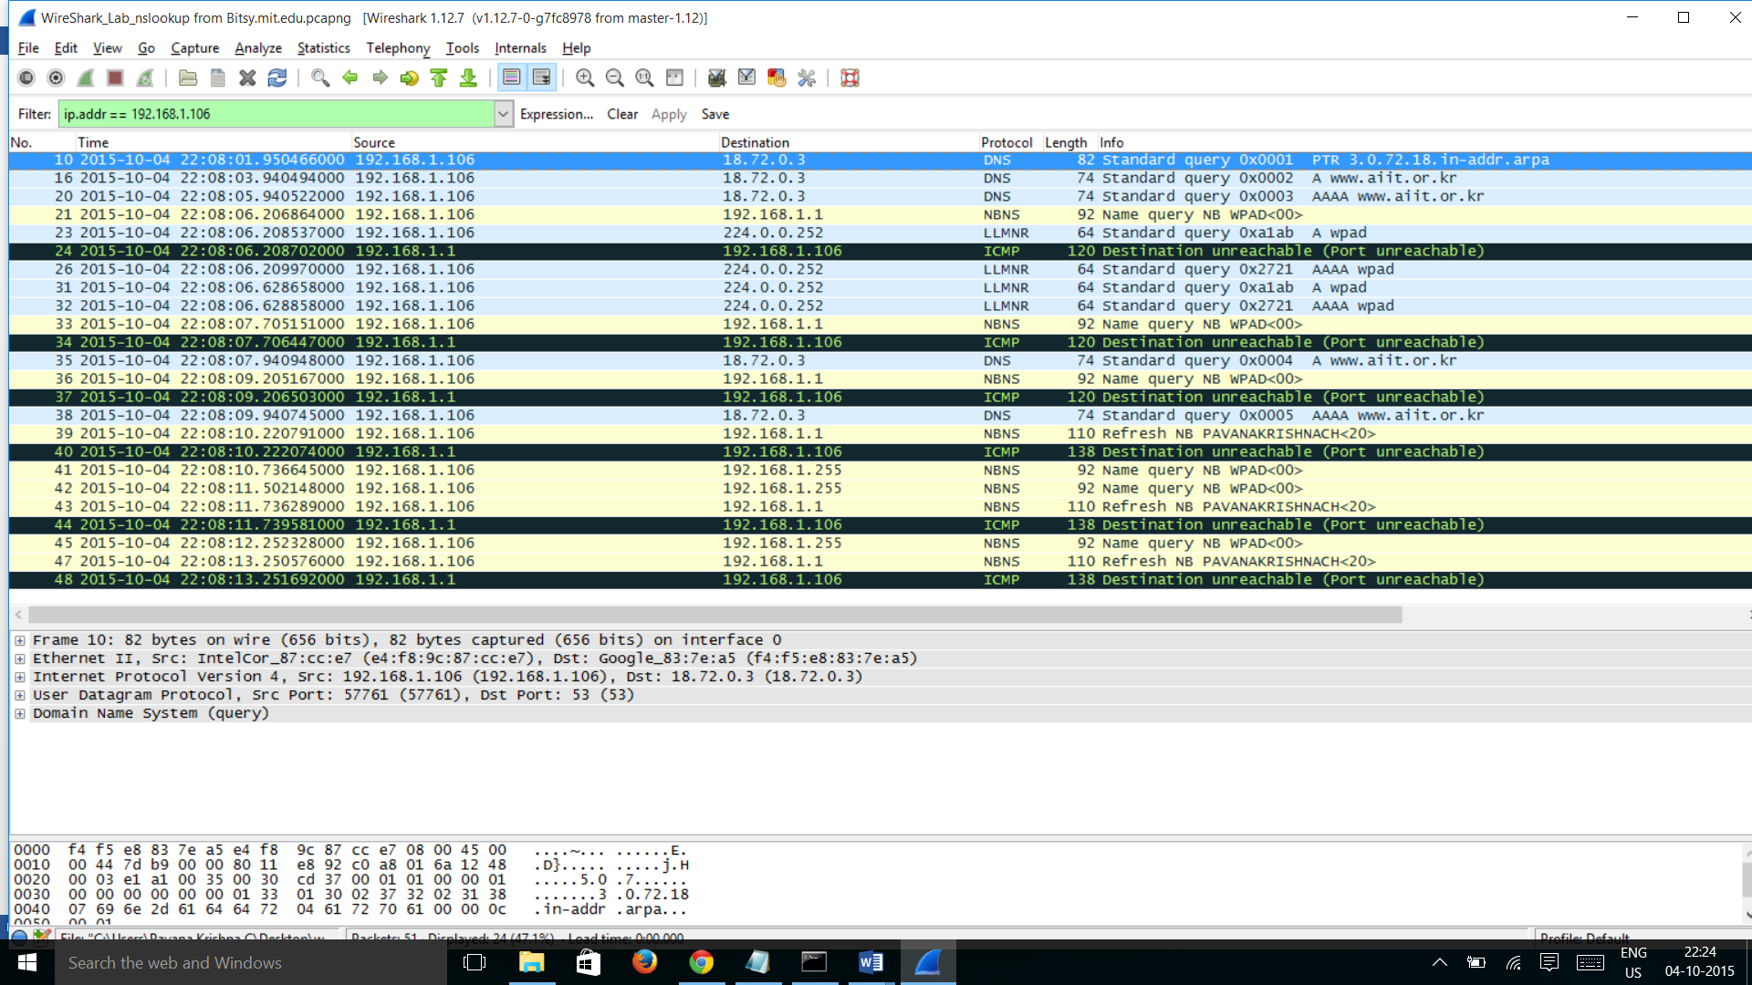

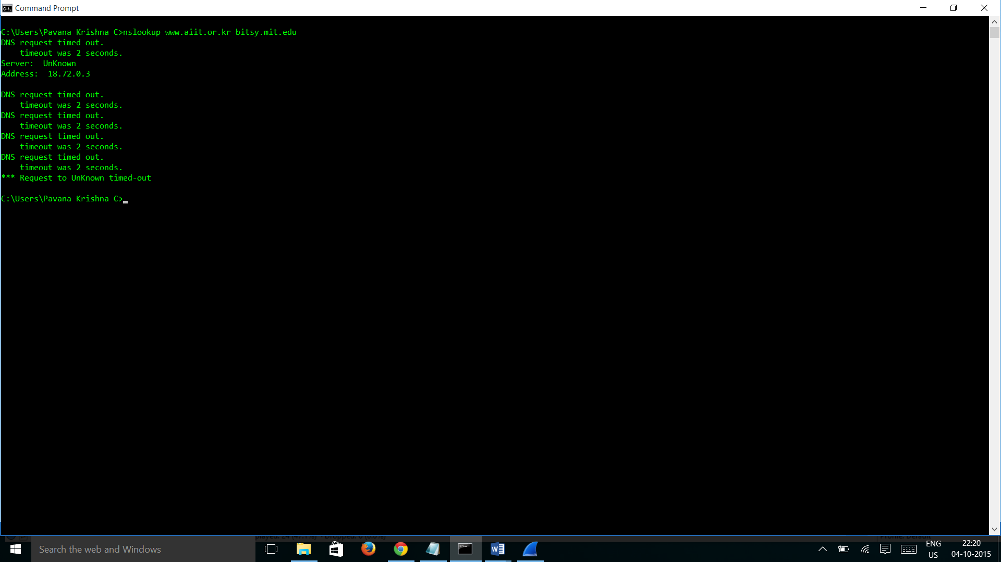

Since we are unable to get the DNS request due to timed-out we did not get the DNS response message from the Bitsy.mit.edu. but Answer will be the same number as the nslookup and it contains Type, websites address, class, time to live etc.